Вопросы к викторине по страноведению для 3-х классов

- What is the name of the country where people speak English?
- What river is in Britain?
- What is Great Britain made of?
- What is the capital of Scotland?
- The capital of Great Britain is…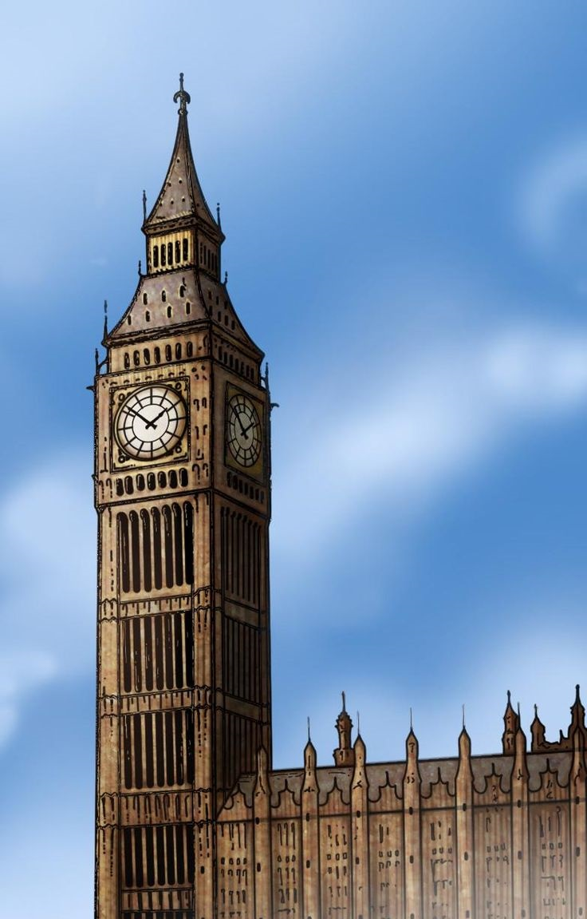

- Who rules the country?
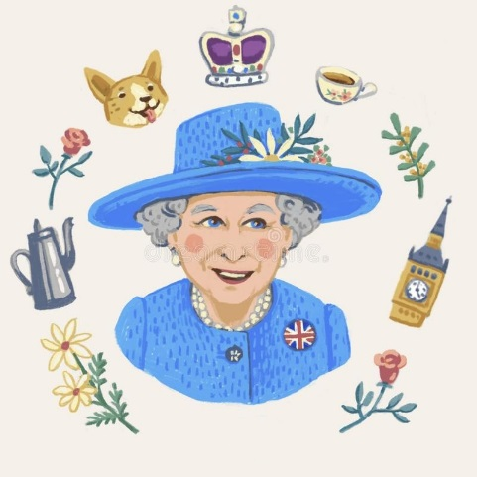
- What is the name of the new year in Britain?
